ATE Typ 200 Brake Fluid Meets the Needs of High-Performance Vehicles
- High boiling point and high viscosity are suitable for a variety of applications
Las Vegas, Nov.4, 2025 – ATE Typ 200 provides the brake fluid performance needed for high-performance vehicle applications. With a minimum boiling point of 536º F and a maximum viscosity of 1,400mm²/second at -40º F, ATE Typ 200 can perform in the most demanding high-performance conditions. ATE Typ 200 has a wet boiling point of 388º F.
According to Nathan Killeen, ATE Brake Systems Product Manager for AUMOVIO, “Over the years, ATE Brake Fluid gained a worldwide following among the high-performance community for our ‘Blue’ brake fluid. ATE Typ 200 surpasses the boiling point performance of our ‘Blue’ fluid, with an amber color that complies with DOT regulations. High-performance enthusiasts will be happy to learn that ATE has a fluid available that will meet or exceed their vehicles’ brake system needs.”
ATE Typ 200 is available in 1-liter cans at auto retailers and online. It is compatible with advanced driver assistance systems, including ESP, ABS, and ASR.
To learn more about ATE Brake Fluids, go to ate-na.com.
AUMOVIO develops pioneering technologies and services that make mobility safe, exciting, connected, and autonomous. Drawing on more than 100 years of partnership with vehicle manufacturers, AUMOVIO Automotive Aftermarket offers a broad range of OE-quality spare parts for the aftermarket. Under the ATE, VDO, and REDI-Sensor brands, the technology company manufactures tens of thousands of products, including brakes, TPMS, ADAS, drive components, and thermal management components. In fiscal year 2024, the company generated sales of over $22.8 billion (USD). AUMOVIO is headquartered in Frankfurt, Germany, and has approximately 86,000 employees in more than 100 locations worldwide.

Press contact

Laura Berger
Head of Marketing and Communications
Automotive Aftermarket
AUMOVIO North America
6755 Snowdrift Road, Allentown, PA 18106
Tel: +1 248-466-9016
Email: laura.berger@aumovio.com

Pictures/captions
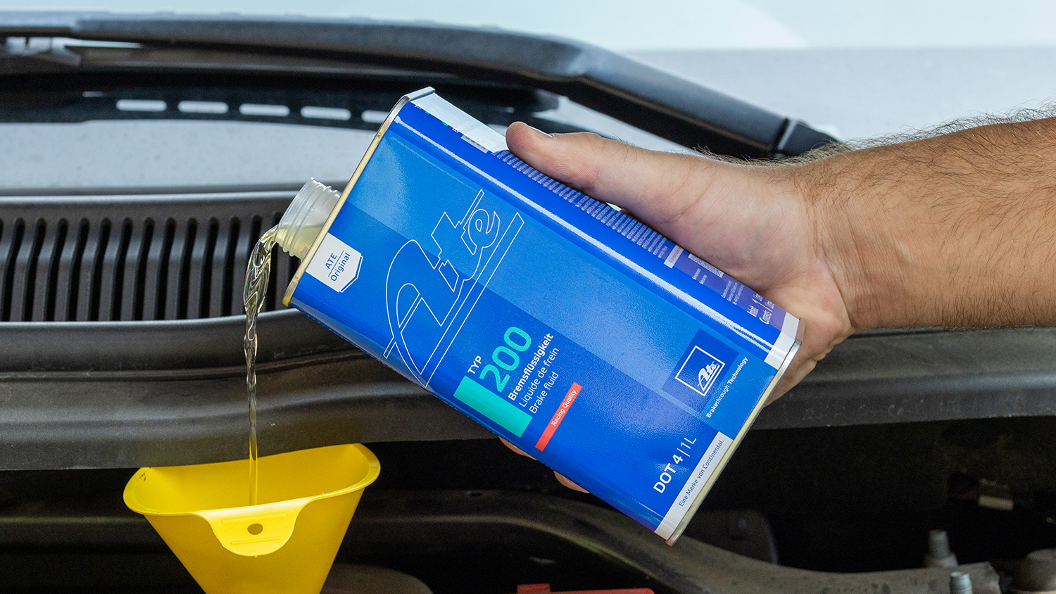
ATE Typ 200 provides the brake fluid performance needed for high-performance vehicle applications.

[Image: ATE Typ 200 Brake Fluid.jpg]

